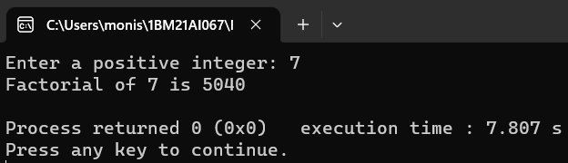

The Output of the Program for the Factorial of a Positive Number.  
  
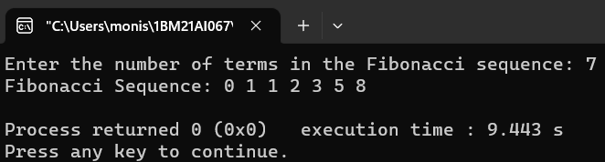

The Output of the Program for the Fibonacci Sequence.  
  
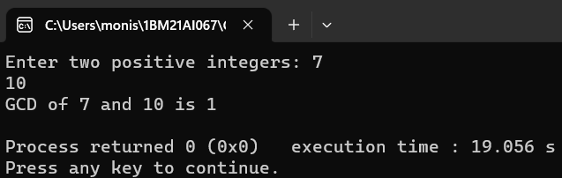

The Output of the Program to find out the Greatest Common Divisor of 2 Positive Integers.

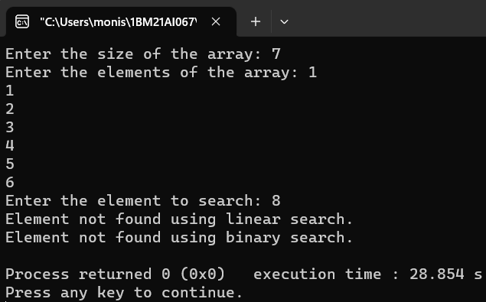

The output of the Program for Linear Search and Binary Search.

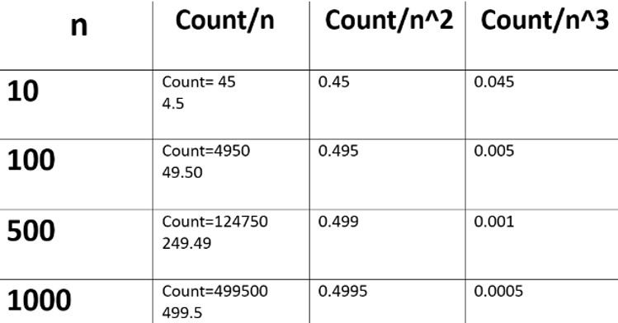

Table for the Time Complexity of Binary Sort.

Graph for the Time Complexities of Linear Search and Binary Search Programs.

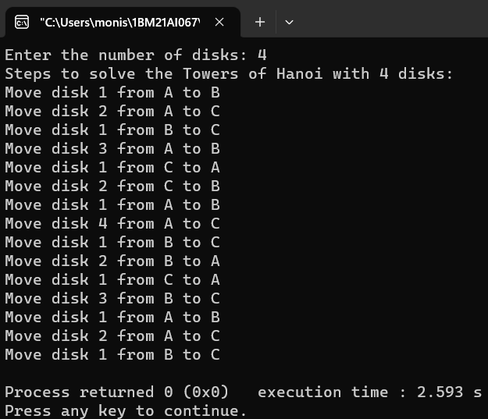

The output of the Program to Solve the Towers of Hanoi Puzzle.

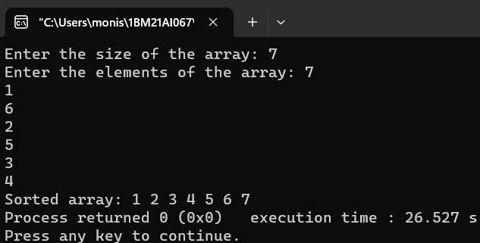

Output for Bubble Sort Program.

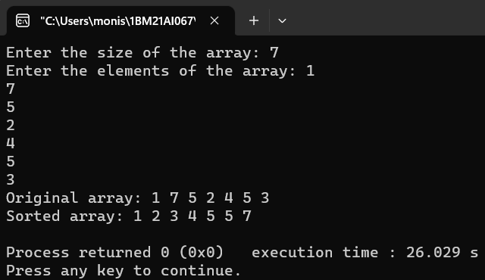

Output for Merge Sort Program.

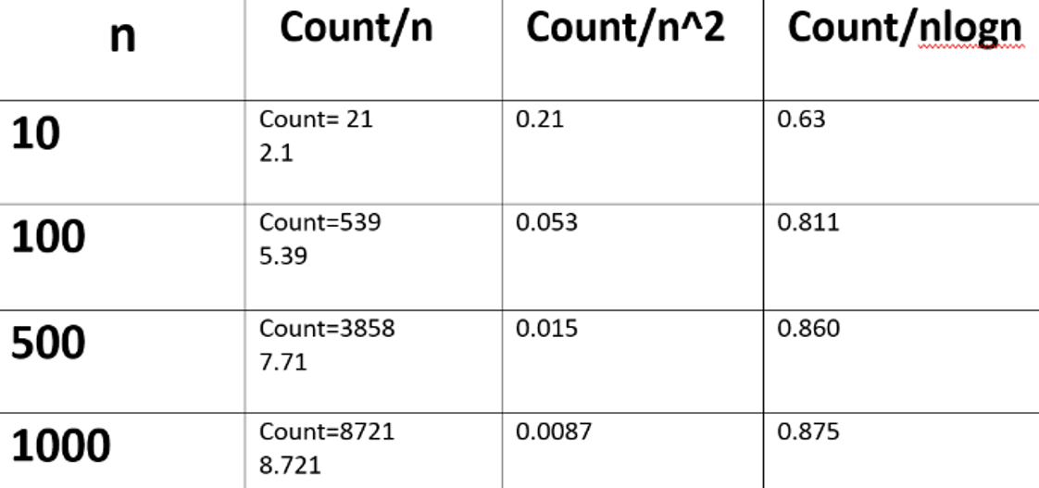

Table for the Time Complexities of the Merge Sort Program.

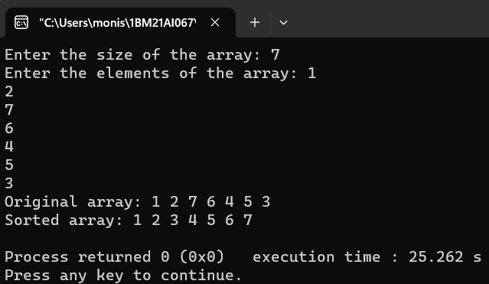

Output of Quick Sort Program.

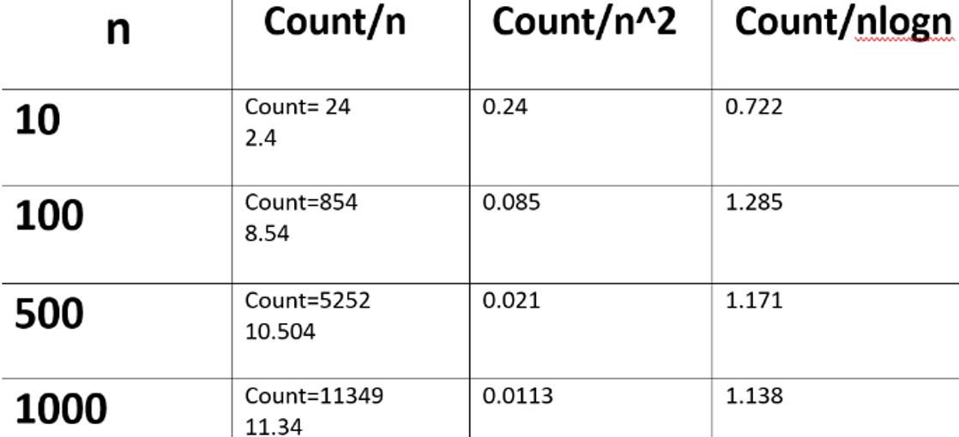

Table for the Time Complexities of the Program for Quick Sort.

Graph for the Time Complexities of the Quick Sort Program.